

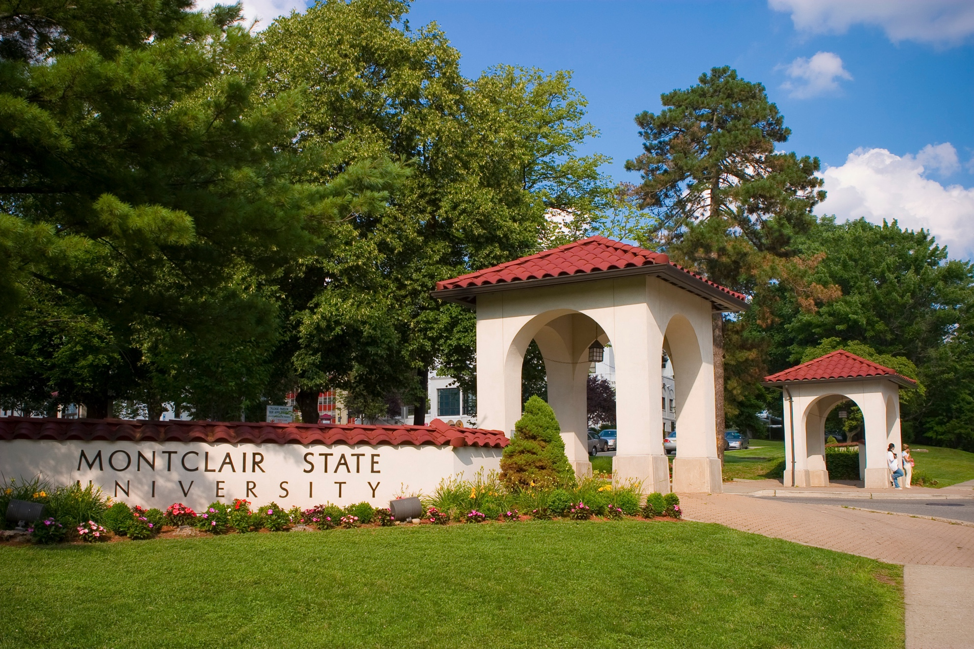
Select Photos from Montclair State’s Gallery: https://montclairstateuniversity.smugmug.com/Gallery/
Optional
QR Code
COLLEGE OR SCHOOL IDENTIFICATION | montclair.edu/xxxxRE

Bio and Additional Information

Lorem ipsum dolor sit amet, consectetur adipiscing elit, sed do eiusmod tempor incididunt ut labore et dolore magna aliqua

Ut enim ad minim veniam, quis nostrud exercitation ullamco laboris nisi ut aliquip ex ea commodo consequat

Duis aute irure dolor in reprehenderit in voluptate

Event Title
Description: Duis aute irure dolor in reprehenderit in voluptate velit esse cillum dolore eu fugiat nulla pariatur. Excepteur sint occaecat cupidatat non proident, sunt in culpa qui officia deserunt mollit anim id est laborum.

Date/Time:
November 24, 2022 at 2 p.m.

Location:
University Hall, 7 Floor Conference Center

Register:
To register and learn more, visit montclair.edu/xxxxx or click below

Contact Information::
Contact

