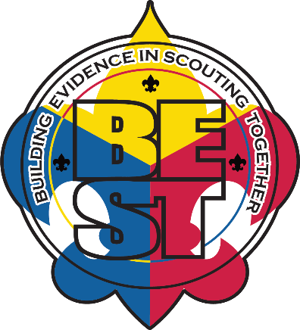
BSA BEST Study
Research Findings Reports, by Research Question
October 2020

- General
  - BEST Study One Pager Overall
  - BEST Study Retention Findings Executive Summary
  - BEST Study Retention Findings Full Report
  - BEST Study High Adventure Executive Summary
  - BEST Study High Adventure Full Report

- RQ 1: What combination(s) of training and experience lead to the most effective (at instilling character outcomes in youth) adult volunteers in Scouts?
  - Preliminary RQ1 results—summary

- RQ 2: How can BSA’s adult trainings and systems be enhanced to strengthen adult practice in support of youth character development? How can this learning be shared with other youth-serving organizations?
  - Data Use Adult Interviews Diversity Report
  - Data Use Youth Interviews Diversity Report
  - Data Use Observation Diversity Report
  - Data Use Survey Diversity Report

- RQ 3: What variations exist in adult training implementation in Boy Scouts?
  - BEST One Pager Fidelity
  - BEST SM Training Fidelity Report
  - Data Use General Training Packet
  - Data Use Training Intro Packet
  - Data Use Training IOLS Packet
  - Data Use Training SMST Packet
  - Data Use Training Wood Badge Packet

